*Uses Monte Carlo simulation methods based on triangular and uniform distributions, histograms and chi-square tests to evaluate goodness of fit.*

**Project**

**2**

P2

ALY6050 Intro to Enterprise Analytics

Project 2 – Benefit-Cost Analysis of Dam Construction Projects

**PREPERATION:**

By: John DiSessa

For: Professor Behboudi

On: March 6th, 2022

Introduction

The JET Corporation asked us to analyze two Dam project proposals. Dam 1 would be in Southwest Georgia and Dam 2 would be in North Carolina. We evaluated the total benefits and total costs of each project based on the following categories. We ran Monte Carlo simulations to predict which project would have the best chance at a higher benefit-cost ratio over 30 years given the expected values (in millions of dollars).

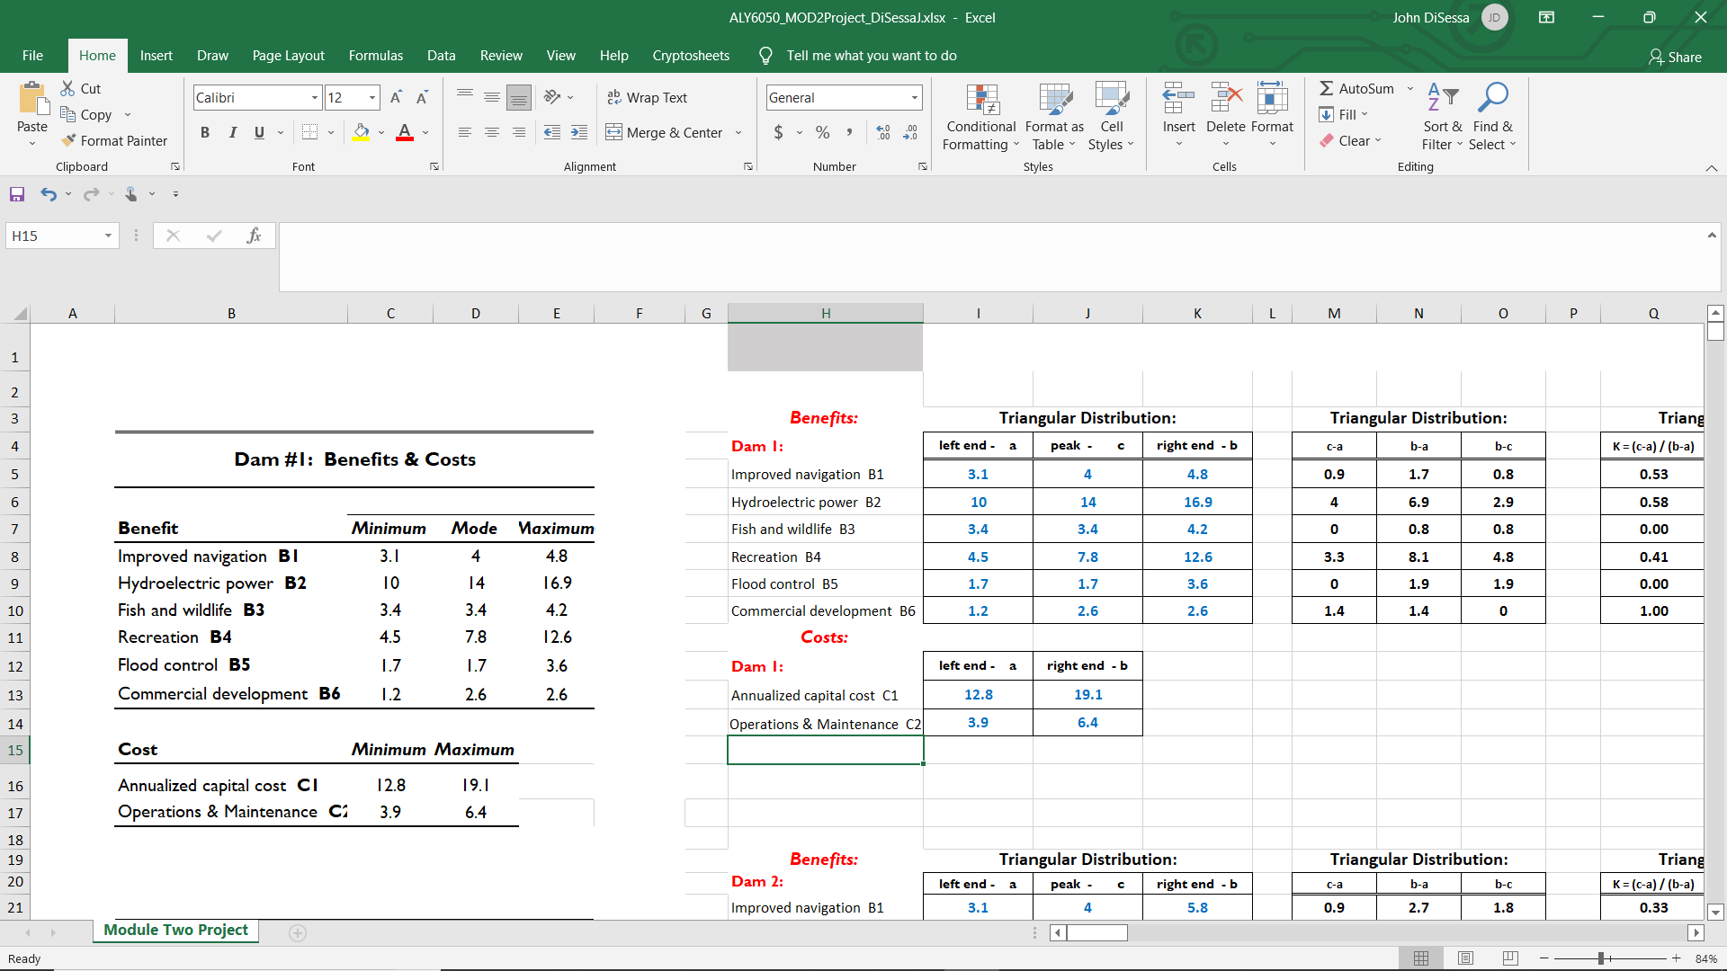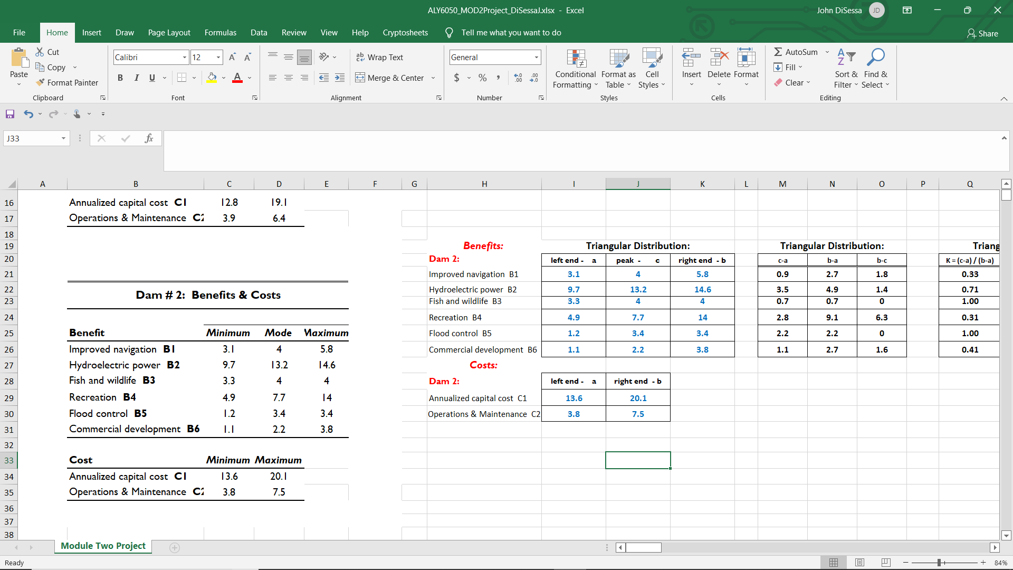

Analysis

We ran a Monte Carlo simulation for each Dam project in order to find a distribution of potential Benefit-cost ratio values based on the given ranges of benefits and costs. The distribution for each simulation is shown below.

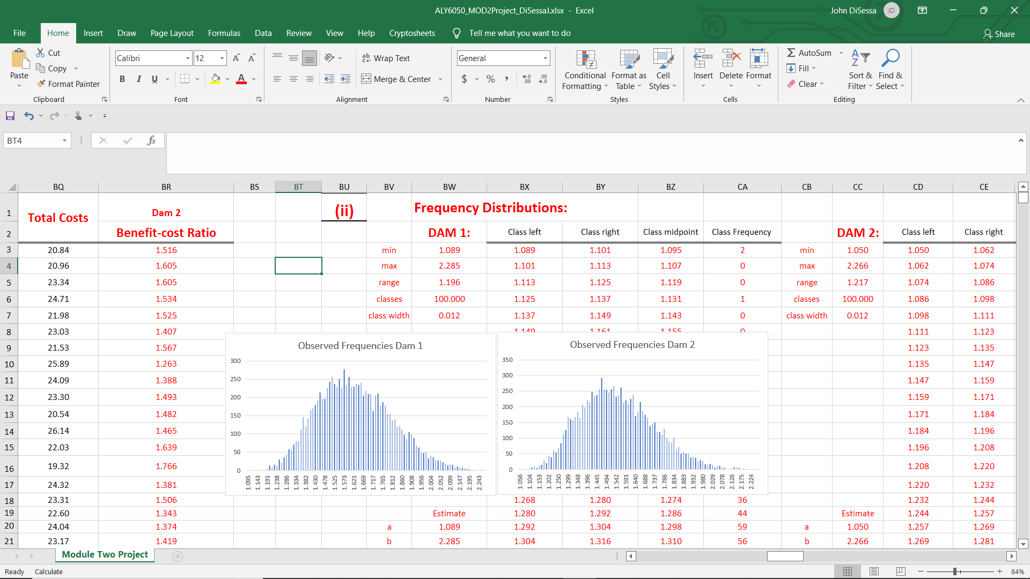

Before deciding which project has a higher expected value, we first need to figure out what kind of distributions we have. At first, I suspected they were normal distributions. However, I created a Q-Q plot and calculated the quartiles to see if the results of our simulations were normally distributed. If the data was normally distributed, we would see the values fit the straight line, and the straight line would be at a 45-degree angle. Neither criterion was met. If the data was normally distributed, there would be an equal distance between the minimum and 1st quartile, 1st quartile and median, median and 3rd quartile, and 3rd quartile and maximum. The differences between them vary quite a bit.

|  |  |
| --- | --- |
| **Metric** | **Value** |
| Minimum | 1.101 |
| 1st Quartile | 1.486 |
| Median | 1.611 |
| 3rd Quartile | 1.751 |
| Maximum | 2.324 |

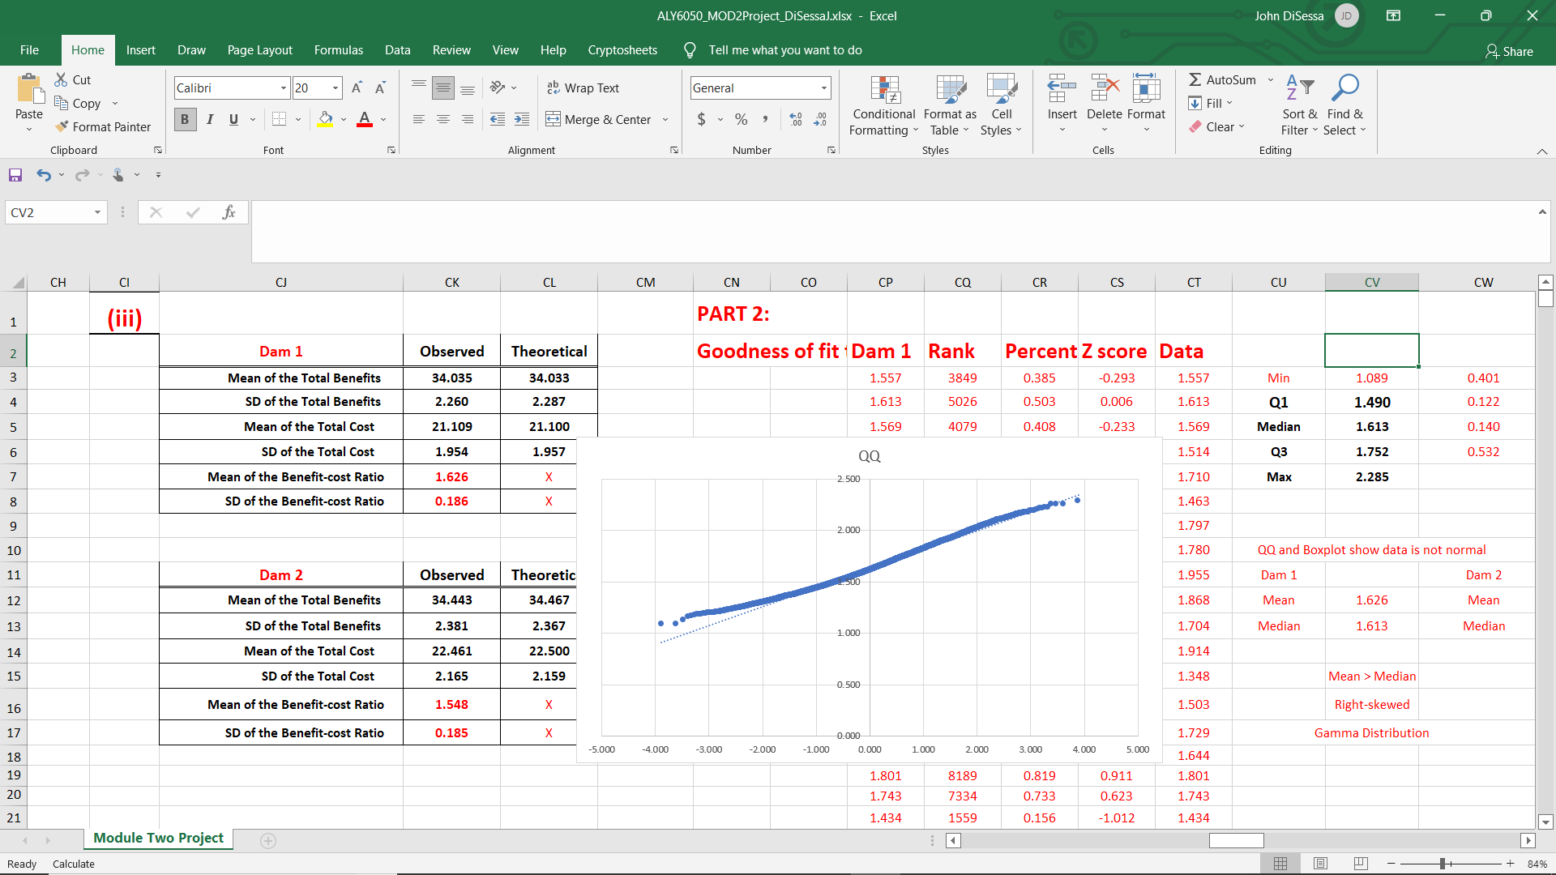

Looking more closely at the data, we can see that it is slightly right skewed more than it is normal. This is confirmed by our mean benefit-cost ratio for Dam 1 (1.626) being higher than our median benefit cost ratio (1.611). It seems very likely that we have a Gamma distribution. However, we ran a Chi-Square Goodness of Fit test to calculate the probability that our simulation results meet the expected results if we did actually have a Gamma distribution.

* H0: Our data belongs to a Gamma distribution
* Ha: Our data does not belong to a Gamma distribution

With an alpha of .05, we calculated p-values almost always equal to 0. Since our p-values were less than .05, we reject the null in favor of the alternative and conclude that out data does not belong to a Gamma distribution. Even though there is a very little chance we have a Gamma distribution and that our data actually fits a Gamma distribution accurately, we can still use it for analysis since it is still a much better fit than a Triangle distribution and is still a good approximation.

Based on our Monte Carlo simulations for each Dam project we calculated our means and standard deviations and compared them to our expected means and standard deviations.

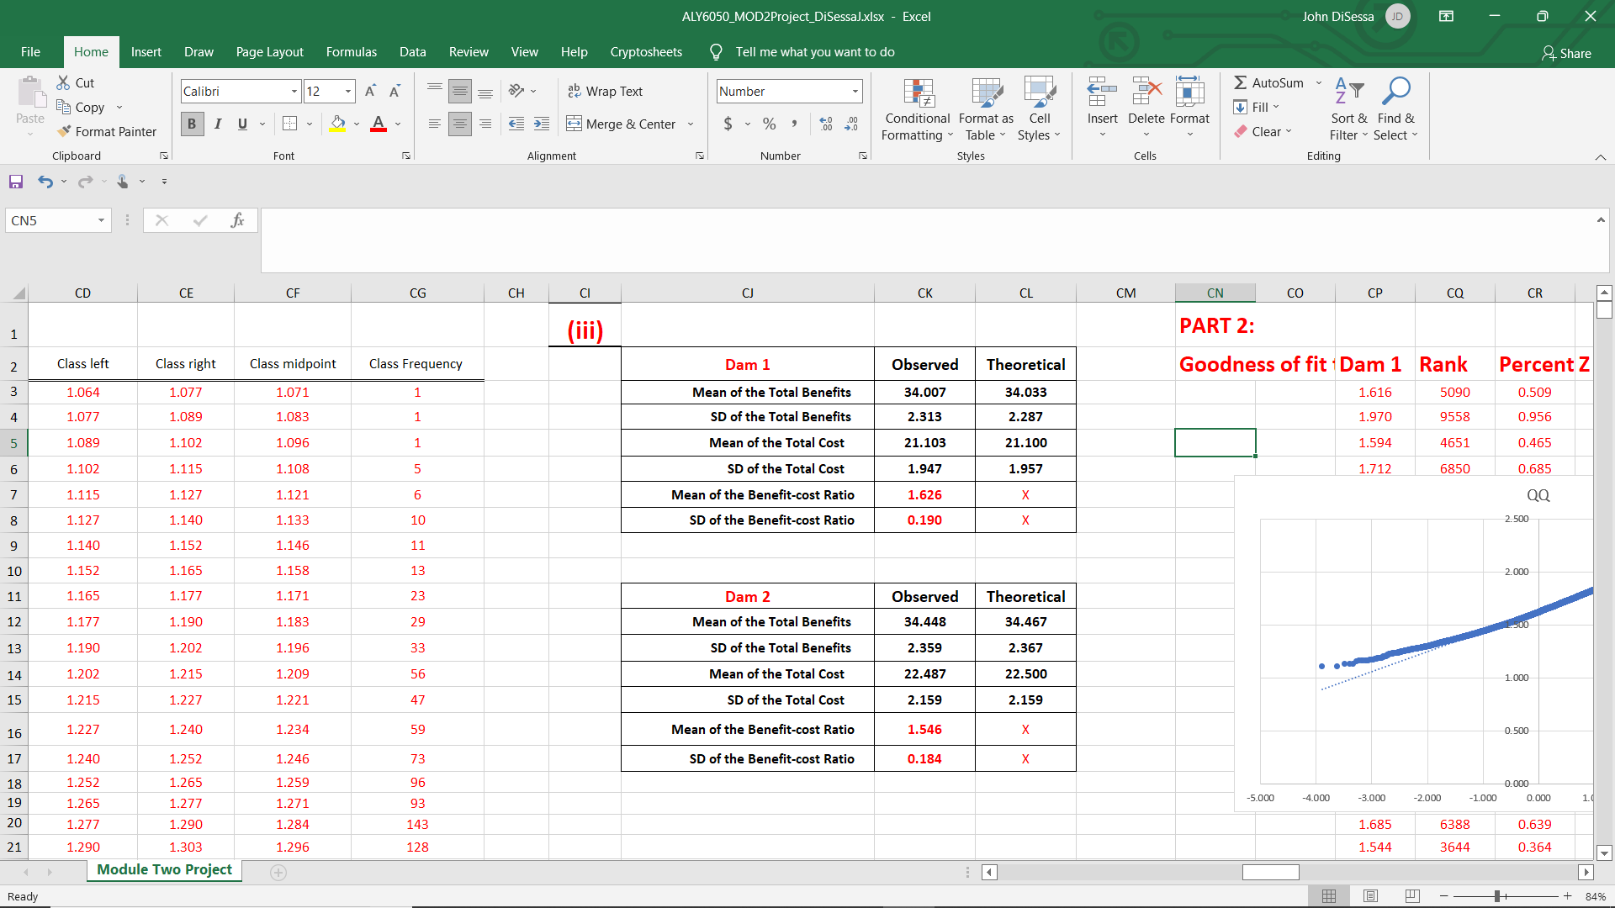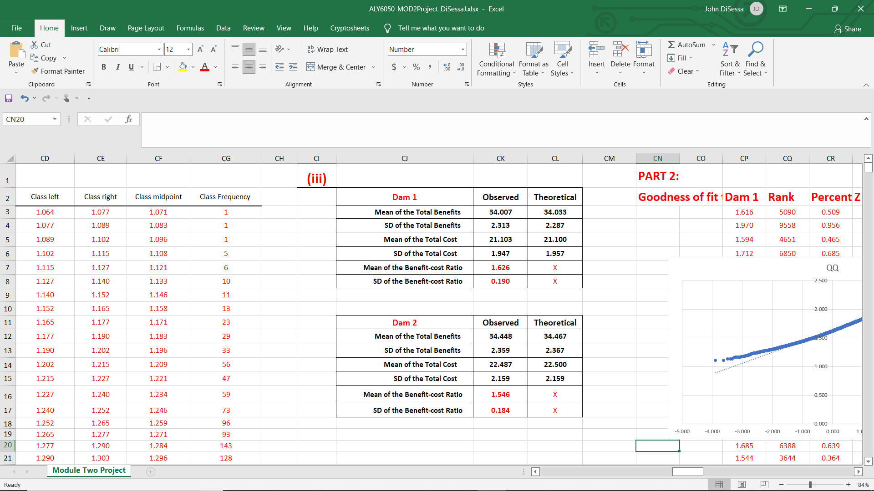

For this iteration, both mean benefits for each project are right about where we expected, with Dam 2 having a higher average. However, it’s observed and expected standard deviation of total benefits are much larger than that of Dam 1 so we can expect more variance and unpredictability. Dam 2’s observed and expected costs are also much higher than Dam 1’s which leads to Dam 1 having the higher Benefit-cost ratio.

Since Benefit-cost ratio is the most important metric in our analysis, we dove deeper into comparing each project’s Benefit-cost ratio.

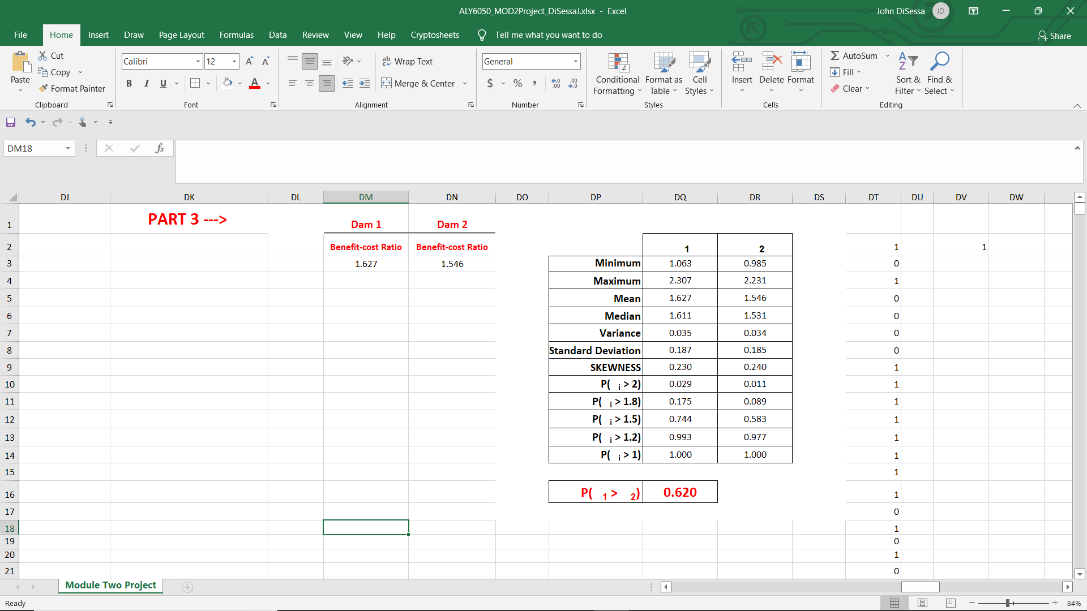

For this same iteration, which is representative of all the other iterations we ran, Dam 1’s Benefit-cost ratio has a higher minimum, maximum, mean, and median despite having approximately the same variance, standard deviation, and skewness as Dam 2. We also calculated the probability of each project having a Benefit-cost ratio greater than 2, 1.8, 1.5, 1.2, and 1. Both projects are expected to be profitable since they have almost a 100% chance of having a Benefit-cost ratio greater than 1. Dam 1, though, has a higher probability of achieving Benefit-cost ratios greater than each of our selected values.

Summary

Our ultimate goal of this analysis was to make a recommendation for which project is more likely to be more profitable. We were given ranges for potential benefits and costs and ran Monte Carlo simulations to best estimate the profitability of each Dam project. Even though our simulations didn’t perfectly fit a Gamma distribution, we still used it because it was still a good enough approximation. Dam 1 generally had much lower costs and the same variability as Dam 2, even though Dam 2 had slightly higher benefits. Based on our simulations, Dam 1 had a higher Benefit-cost ratio than Dam 2 62% of the time. It is certainly possible that Dam 2 could become more profitable, but our analysis determined that Dam 1 has the higher chance of being more profitable. With a higher chance of being more profitable and have the same variability, Dam 1 is the logical choice and our final recommendation to JET Corporation.